Test Case 2

**Section:** Log In

**Check :** Log In with Facebook

**Precoidition**

Open cite <https://rozetka.com.ua/ua/>

**Step 1:**

Press the line Log in with Facebook

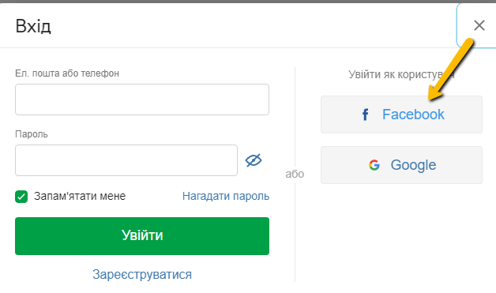

Expected Results

Must be opening icon Facebook

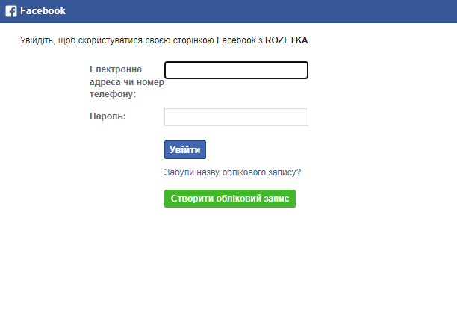

**Step 2:**

Entered correct information to Log in with Facebook

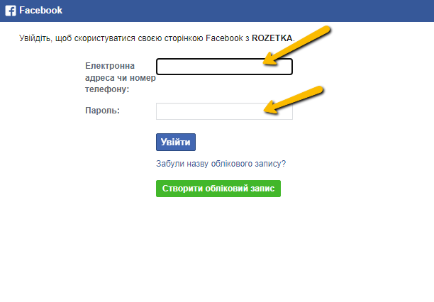

Expected Results

Confirm Facebook Account to log in with Facebook on site Rozetka

